
SATURDAY, AUGUST 17, 1935 (Note: the wedding was actually August 16)

Miss Elizabeth Marrack is Bride of
Lieut. Charles G. Dodge in Palo Alto

Picturesque Ceremony Held in Garden of Mother’s Home in Presence of Guests

By Cholly Franciso
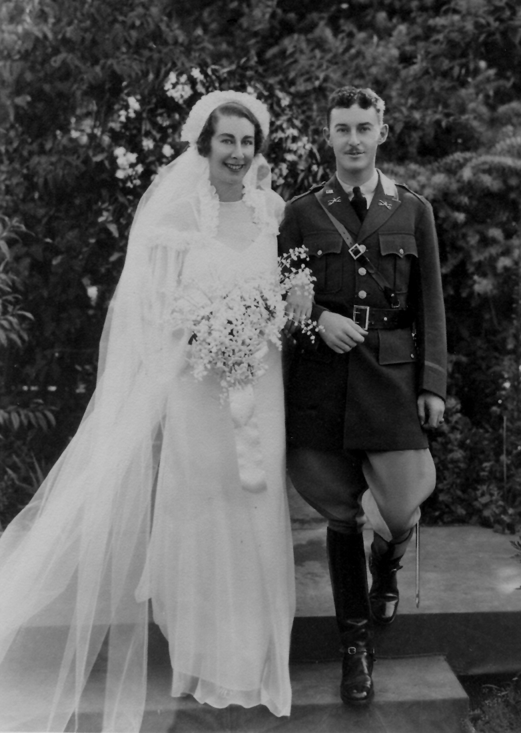
DOWN A GARDEN PATH, hedged with cavalry yellow zinnias, the bridal procession for Miss Elizabeth Marrack and Lieut. Charles Granville Dodge walked yesterday to an alter of white flowers at the end, lighted with tall white candles in wrought iron candelabra. The ceremony was held at 4 o’clock, at the home of the bride’s mother, Mrs. Cecil Marrack, in Palo Alto, with 120 guests admiring the setting which had been designed and planted in early spring.
White chiffon formed the bridal gown, made on princess lines with very full sleeves. The long tulle veil hung from a lace coronet, an old rose point heirloom of four generations past, held with knots of orange blossoms. The bride carried lilies of the valley and orchids.
The bridesmaid, Miss Cecil Marrack, wore a chiffon gown of cavalry yellow with a brown velvet belt, made with pleated ruffles and a ruffled cape. She carried yellow and brown-eyed susans, and the ensemble was completed by the yellow garden hat, which was pleated to match the costume.
Lieut. James Q. Brett was best man, a classmate of the groom’s at West Point. The ushers were Lieut. Birrell Walsh, Lieut. E. W. Suarez, Lieut. Marvin Harding, Lieut. A. K. Dodson, Lieut. W. M. Garland, Lieut. R. T. King, Lieut. Mullard Lewis and Capt. William J. Etes.
A buffet supper followed the ceremony, after which the couple left for a short honeymoon motor tour. They will return to Palo Alto before leaving on August 23 for Fort Riley, Kansas, their new home.
Mrs. Marrack, mother of the bride, wore a beige lace costume, with matching hat and an orchid corsage, and Miss Harriet Marrack, sister of the bride, was in flowered chiffon, with a green garden hat.
The bride is the daughter of the late Rev. Cecil Marrack of San Francisco and the granddaughter of Mrs. Febiger and the late Col. Lea Febiger, who was in command of the Presidio some years ago.
A graduate of the University of California, she previously studied at Castilleja School and is a member of Alpha Phi.
Lieut. Dodge is the son of Mr. And Mrs. E. G. Dodge of Boston and was graduated from West Point with the class of 1930.
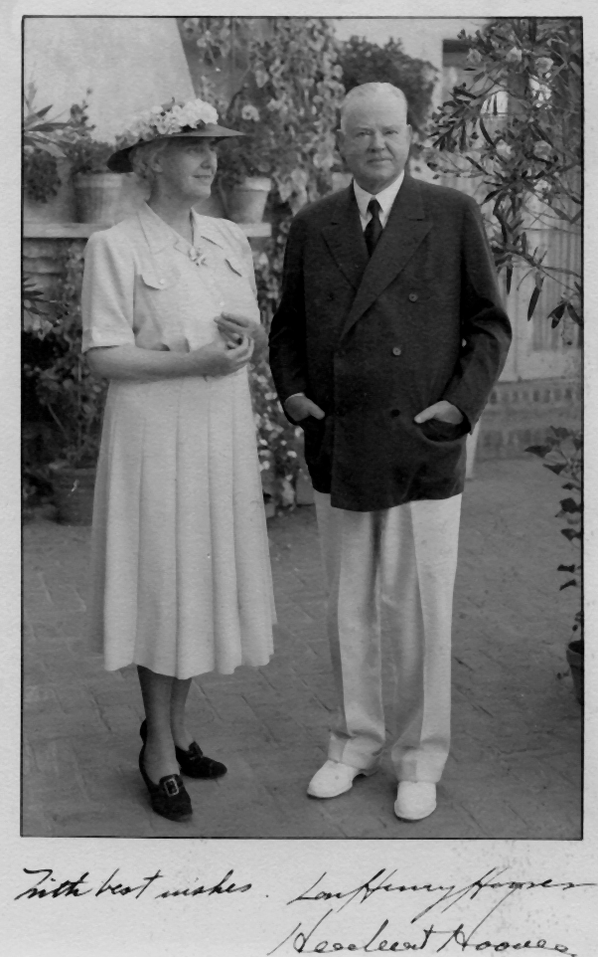

NOTE: The Hoovers (as in President Hoover) lived nearby in his retirement, and they were friends of Tutu (the mother of the bride). Herbert Hoover offered to be the best man, but Mom declined because she thought his role in the wedding might draw attention away from the wedding itself—not to mention from her and Dad. In lieu of that, Hoover loaned them his limousine for their “get-away” car. ~ Sue & Ty Dodge

