Charles Granville Dodge
Awards for Military Service
(Shown in order of precedence.)

 | DISTINGUISHED SERVICE MEDAL  The Distinguished Service Medal is awarded to any person who, while serving in any capacity with the United States Army, has distinguished himself or herself by exceptionally meritorious service to the Government in a duty of great responsibility. The performance must be such as to merit recognition for service which is clearly exceptional. Exceptional performance of normal duty will not alone justify an award of this decoration.  For service not related to actual war, the term "duty of a great responsibility" applies to a narrower range of positions, than in time of war, and requires evidence of conspicuously significant achievement. However, justification of the award may accrue by virtue of exceptionally meritorious service in a succession of high positions of great importance.
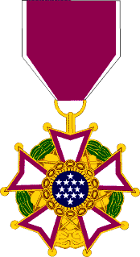 | LEGION OF MERIT (Legionnaire)  The Legion of Merit is awarded to all members of the Armed Forces of the United States without reference to degree for exceptionally meritorious conduct in the performance of outstanding services and achievements. The performance must have been such as to merit recognition of key individuals for service rendered in a clearly exceptional manner. Performance of duties normal to the grade, branch, specialty or assignment, and experience of an individual is not an adequate basis for this award. For service not related to actual war the term "key individual" applies to a narrower range of positions than in time of war and requires evidence of significant achievement. In peacetime, service should be in the nature of a special requirement or of an extremely difficult duty performed in an unprecedented and clearly exceptional manner. However, justification of the award may accrue by virtue of exceptionally meritorious service in a succession of important positions.
 | BRONZE STAR  The Bronze Star Medal is awarded to any person who, while serving in any capacity in or with the military of the United States after 6 December 1941, distinguished himself or herself by heroic or meritorious achievement or service, not involving participation in aerial flight, while engaged in an action against an enemy of the United States; while engaged in military operations involving conflict with an opposing foreign force; or while serving with friendly foreign forces engaged in an armed conflict against an opposing armed force in which the United States is not a belligerent party.
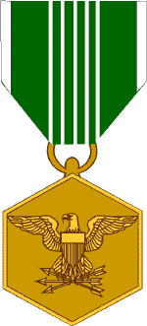 | ARMY COMMENDATION MEDAL  The Army Commendation Medal is awarded to any member of the Armed Forces of the United States other than General Officers who, while serving in any capacity with the Army after 6 December 1941, distinguished himself/herself by heroism, meritorious achievement or meritorious service.  Awards may be made for acts of valor performed under circumstances described above which are of lesser degree than required for award of the Bronze Star Medal. These acts may involve aerial flight. An award may be made for acts of noncombatant-related heroism which do not meet the requirements for an award of the Soldier’s Medal.
 | AMERICAN DEFENSE SERVICE MEDAL  The American Defense Service Medal was awarded to personnel for active duty service from 8 September 1939 to 7 December 1941 for a period of twelve months or longer.
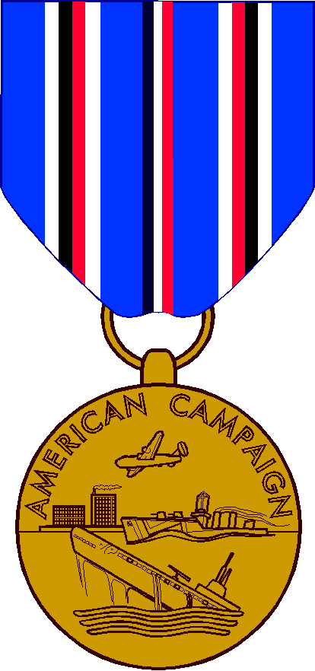 | AMERICAN CAMPAIGN MEDAL  The American Campaign Medal was awarded to personnel for service within the American Theater between 7 December 1941 and 2 March 1946 under any of the following conditions (of the six listed, the two that most likely apply are shown): 1) on permanent assignment outside the continental limits of the United States, and 2) in active combat against the enemy and was awarded a combat decoration or furnished a certificate by the commanding general of a corps, higher unit, or independent force that he actually participated in combat, 6) within the continental limits of the United States for an aggregate period of one year.
 | EUROPEAN-AFRICAN-MIDDLE EASTERN CAMPAIGN MEDAL  The European-African-Middle Eastern Campaign Medal was awarded to personnel for service within the European-African-Middle Eastern Theater between 7 December 1941 and 8 November 1945 under any of the following conditions: 1) on permanent assignment, 2) in a passenger status or on temporary duty for 30 consecutive days or 60 days not consecutive, 3) in active combat against the enemy and was awarded a combat decoration or furnished a certificate by the commanding general of a corps, higher unit, or independent force that he actually participated in combat.
 | WORLD WAR II VICTORY MEDAL  The WW II Victory Medal was awarded to all military personnel for service between 7 December 1941 and 31 December 1946.
 | ARMY OF OCCUPATION MEDAL (with Germany clasp)  The medal was awarded for 30 days consecutive service while assigned to (of the 6 assignments listed, the one that applies is shown): Germany (excluding Berlin) between 9 May 1945 and 5 May 1955, and 2) Austria between 9 May 1945 and 27 July 1955.
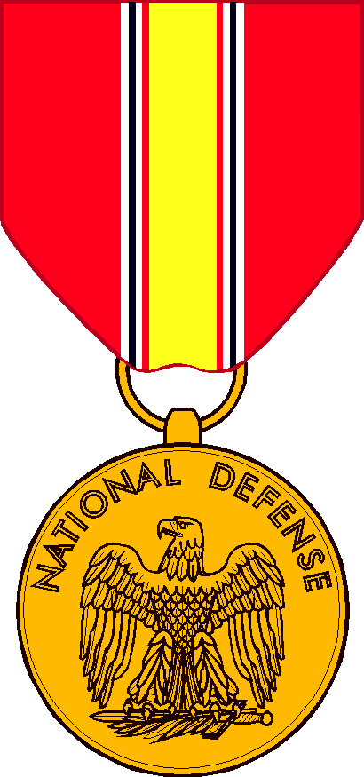 | NATIONAL DEFENSE SERVICE MEDAL  The National Defense Service Medal was awarded for honorable active service for any period between 27 June 1950 and 27 July 1954; between 1 January 1961 and 14 August 1974; between 2 August 1990 and 30 November 1995 and between 11 September 2001 and a closing date to be determined.

AWARDS GIVEN BY OTHER COUNTRIES
Order of Orange Nassau
Knight Grand Cross with Swords
Netherlands
Czechoslovakian War Cross
1939
Czechoslovakia
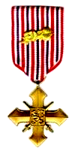
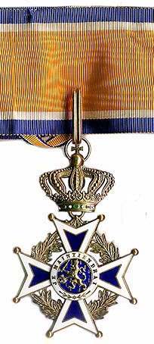

Croix de Guerre Avec Palame
France

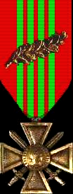

Order of Leopold Avec Palame
Belgium
Croix de Guerre with Palm
1940
Belgium


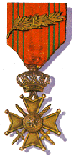

Also the Russian Award of Guard (for which no photo is found).

